Project Design Phase-I Solution Architecture

|  |  |
| --- | --- |
| **NM ID** | **76860632B2D43EFBE814FEC16F13E5E4** |
| **Project Name** | **How To Add Google Analytics To A Website** |

# Solution Architecture:

Solution architecture is a complex process – with many sub-processes – that bridges the gap between business problems and technology solutions. Its goals are to:

* Find the best tech solution to solve existing business problems.
* Describe the structure, characteristics, behaviour, and other aspects of the software to project stakeholders.
* Define features, development phases, and solution requirements
* Provide specifications according to which the solution is defined, managed, and delivered.The solution architecture of my project “How To Add Google Analytics To A Website “ is shown below.

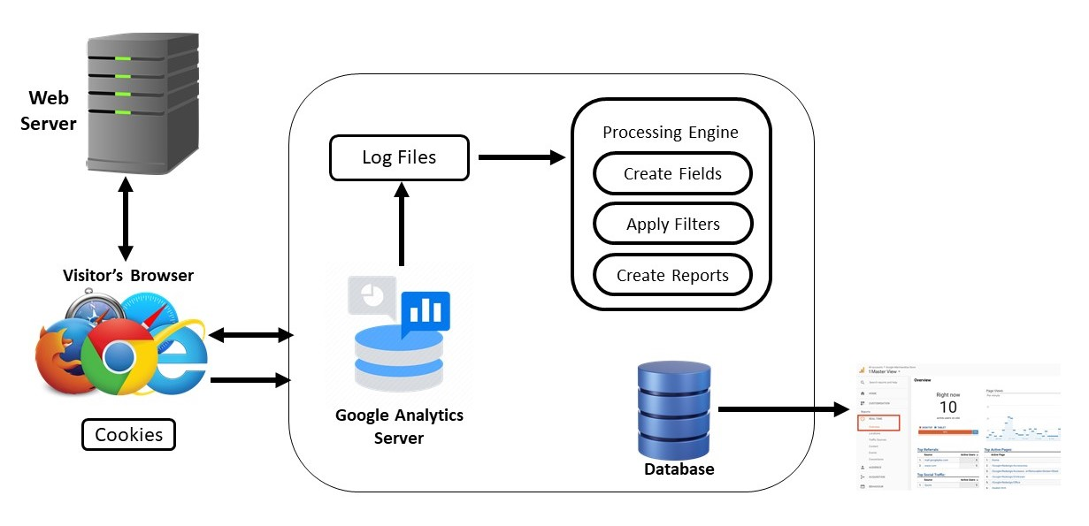

# Flow of a Project:

The data flow of my project is discussed with step by step process as below.

**1. Planning**:- Define your goals for using Google Analytics, such as tracking website traffic, user behavior, conversions, etc.

**2. Create a Google Analytics Account:** - If you don't already have one, sign up for a Google Analytics account at [https://analytics.google.com/](https://analytics.google.com/).

**3. Set Up a Property:** - In Google Analytics, create a new property for your website. You'll need to enter your website's URL and other details.

4**. Get Your Tracking Code:-** After setting up the property, you'll be provided with a tracking code (a snippet of JavaScript). Copy this code.

5. **Implement the Tracking Code:** - You need to add the tracking code to your website. The exact steps for doing this depend on your website platform (e.g., WordPress, HTML, etc.).

Common methods include:- For HTML websites: Paste the tracking code just before the closing </head> tag on every page.

6**. Verify Tracking Code Installation**: Go back to Google Analytics and check if the tracking code is working correctly. It may take some time for data to appear.

7**. Set Up Goals and Events**: - Configure goals and events within Google Analytics to track specific actions or conversions on your website (e.g., form submissions, button clicks).

8. **Customize Tracking**: - Customize your tracking settings in Google Analytics, such as excluding your own visits or tracking e-commerce data if applicable.

9**. View Reports**:- Once data starts flowing into Google Analytics, you can access a wide range of reports to analyze user behavior, traffic sources, and more.

10**. Regular Monitoring**:- Continuously monitor your Google Analytics data to gain insights and make data-driven decisions for your website.

11. **Documentation**: - Document the setup and configurations for future reference and to help others who may work on the website.

12. **Optimize:-** Use the insights from Google Analytics to optimize your website for better user experience and achieving your goals.

13. **Stay Informed**: - Keep up with Google Analytics updates and best practices to make the most of the data it provides.